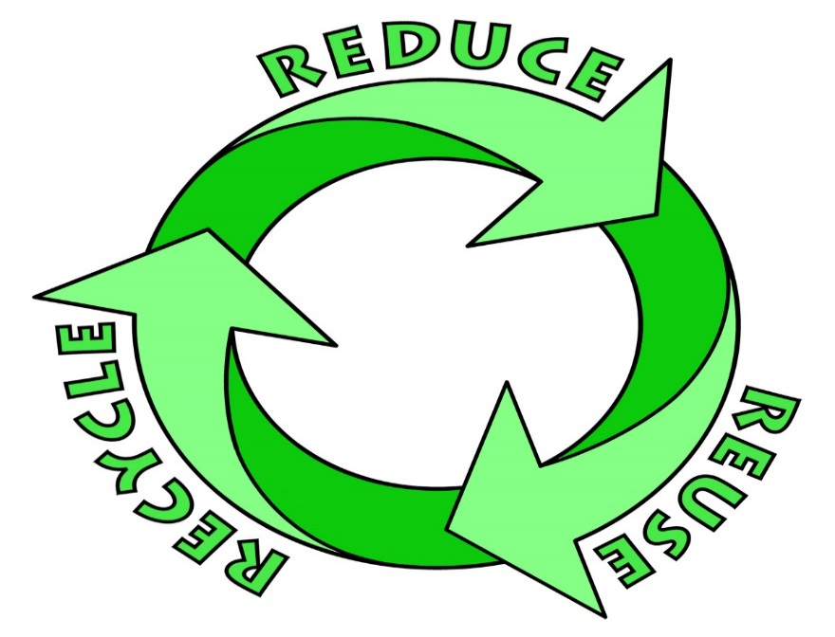

AMERICA RECYCLES DAY - NOVEMBER 15, 2019
JOIN US IN RECYCLING MORE
TAKE THE PLEDGE TO:

LEARN:
Find out what materials are collected in my community
ACT:
Reduce the amount of waste you are producing, recycle more and consider buying products made with recycled materials or content
SHARE:
Encourage family and friends to take the #BeRecycled pledge at www.americarecyclesday.org.

Together we can Keep America Beautiful!

